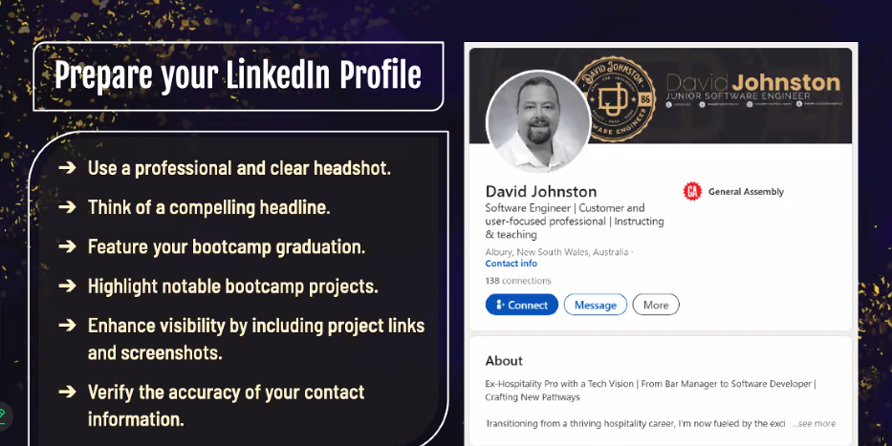

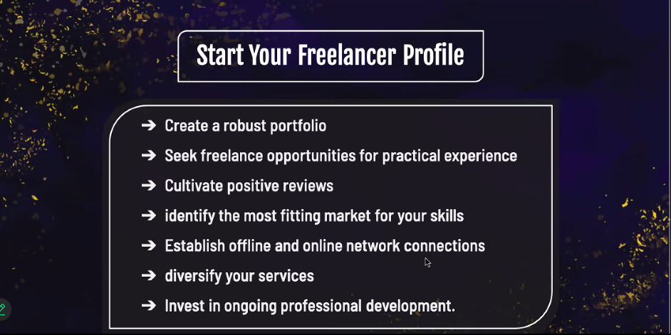

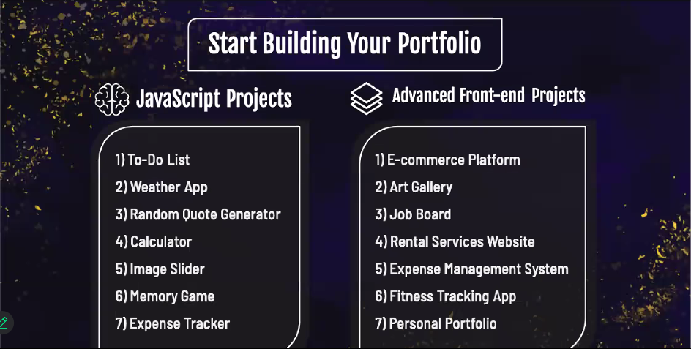

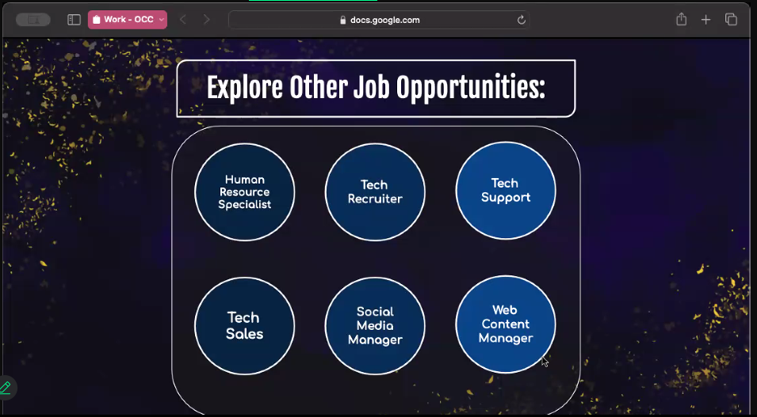

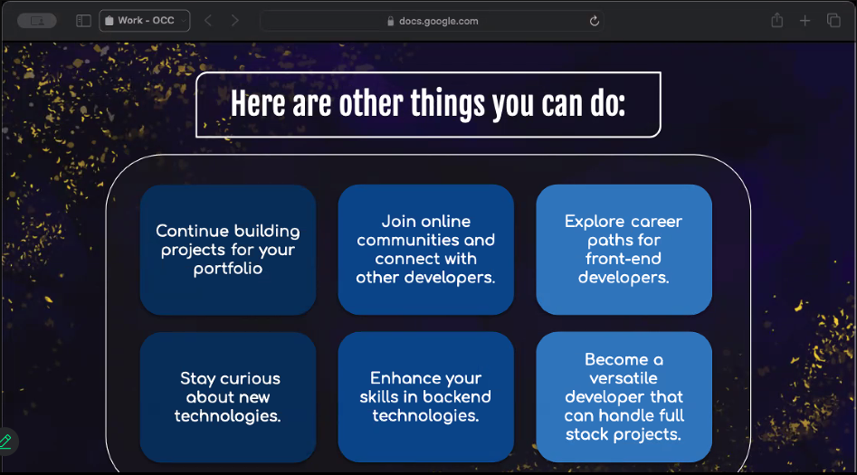

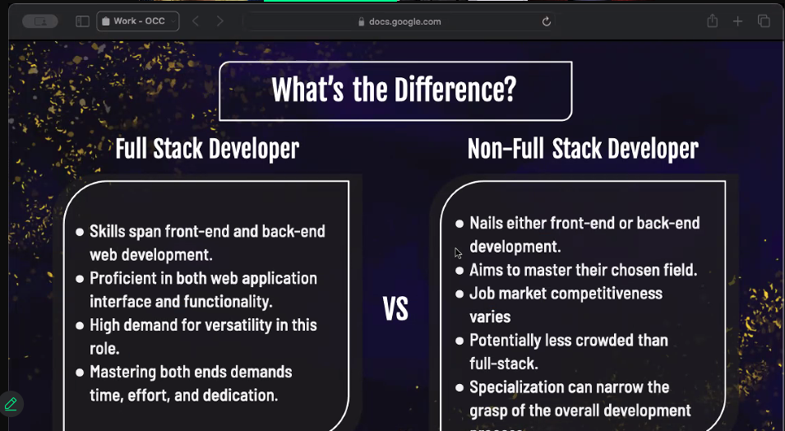

*https://www.linkedin.com/in/d*  
  
**Princess** 7:14 PM  
Reply here your LinkedIn   
  
**Jimmu Orejo** 7:14 PM  
https://www.linkedin.com  
  
**Joseph Mendoza** 7:14 PM  
https://www.linkedin.com/in/jmendoza1012/  
  
**Ronilo Villamor** 7:14 PM  
https://www.linkedin.com/in/ronilo-villamor-ba7068213/  
  
👋  
  
**Richard Dionido** 7:14 PM  
www.linkedin.com/in/richard-dionido-2b2987292  
  
**Jason Carl Leano** 7:14 PM  
www.linkedin.com/in/jason-carl-leano-97a74b204  
  
**Jason Pepito** 7:14 PM  
https://www.linkedin.com/in/jasonz08/  
  
**Enrico Mendoza** 7:14 PM  
https://www.linkedin.com/in/enrico-mendoza-7440162b0/  
  
**Richard James Reyes** 7:15 PM  
https://www.linkedin.com/in/richard-james-reyes-5089872a/  
  
**Princess** 7:15 PM  
https://www.linkedin.com/in/princessalynueles/  
  
**ni so** 7:15 PM  
https://www.linkedin.com/in/ni-so-4b3aa5319/  
  
**Ivan Olan** 7:15 PM (Edited)  
https://www.linkedin.com/in/inolan29  
  
**Buhayang, Ian Kenneth C.** 7:16 PM  
https://www.linkedin.com/in/ian-kenneth-buhayang-09382518a/  
  
**You** 7:16 PM  
[www.linkedin.com/in/caryl-lyn-bual-293022270](http://www.linkedin.com/in/caryl-lyn-bual-293022270)

**Princess** 7:10 PM  
https://info.cern.ch/hypertext/  
  
**Princess** 7:11 PM  
https://olaolu.dev/  
https://www.alpaycelik.dev/#home  
  
**Princess** 7:12 PM  
*https://www.linkedin.com/in/davejohno/*  
  
**Gian Fajardo** 7:14 PM  
<https://www.linkedin.com/in/gian-fajardo-44b236263/>

**Christian Lee** 7:16 PM  
<https://www.linkedin.com/in/christian-lee-286725225/>

**Errol Sarmiento** 7:25 PM  
<https://www.linkedin.com/in/errol-sarmiento-01a2141b6/>

Free hosting websites

netlify  
vercel

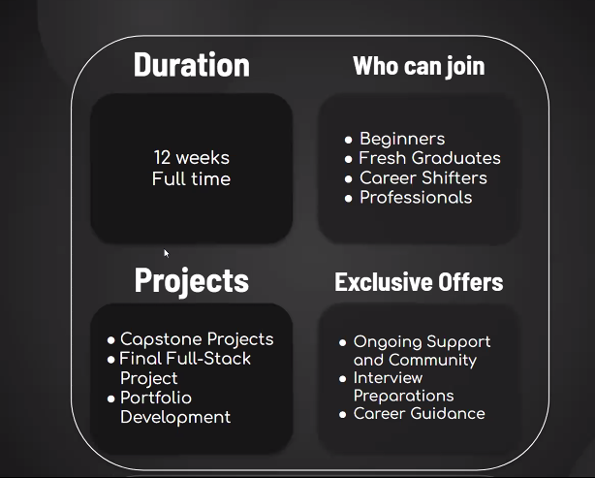

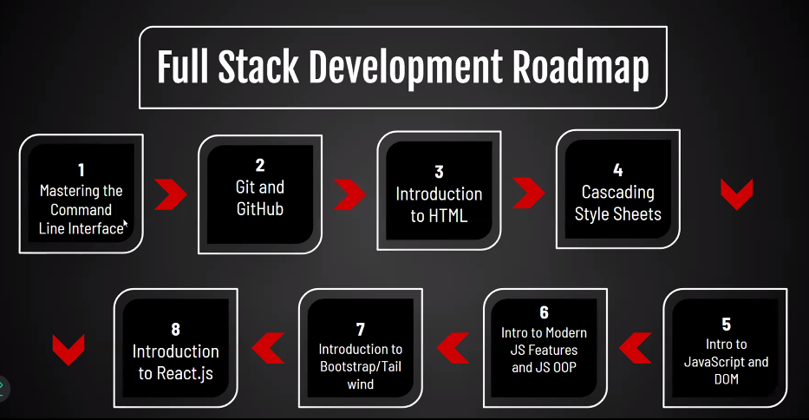

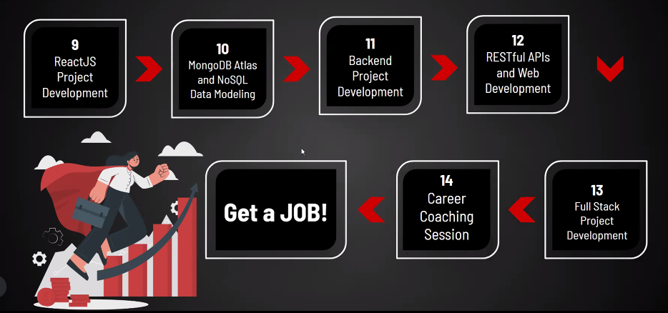



https://docs.google.com/document/d/19M9lHHUV2k791pvfmXnv1uTZMJ5w2oEfhe7qGMTnYH4/edit